America, America
November 12th, 2022

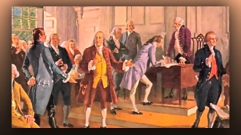
Hello Org Date: June 28, 2014

Oh, beautiful for spacious skies, and purple mountains majesty.
For amber waves of love to die.

America, America, when will you turn your eyes to Him, To Him who longs to heal their pain.

Oh, beautiful for pilgrim's pride, the way across the wilderness.

What once was found is all but lost, and now our faults we must confess.

America, America, when will you turn your eyes to Him?

To Him who longs to heal their pain.

Oh, Beautiful for patriot's dream, and still we seek such nobleness.

For alabaster cities gleam to crown our hearts will false success.

America, America, God shed His grace on thee.

Prepare your blood with brotherhood with Him who longs to heal their pain, who longs to heal their pain.

